How to operate the Automatic Deck Panel

The motorized system gets activated when operated through a switch or remote. Once activated, the motorized mechanism moves the front fabric of the motorized retractable deck for swimming pool, which pushes the deck out when the system is deployed and backward when it is retracted.

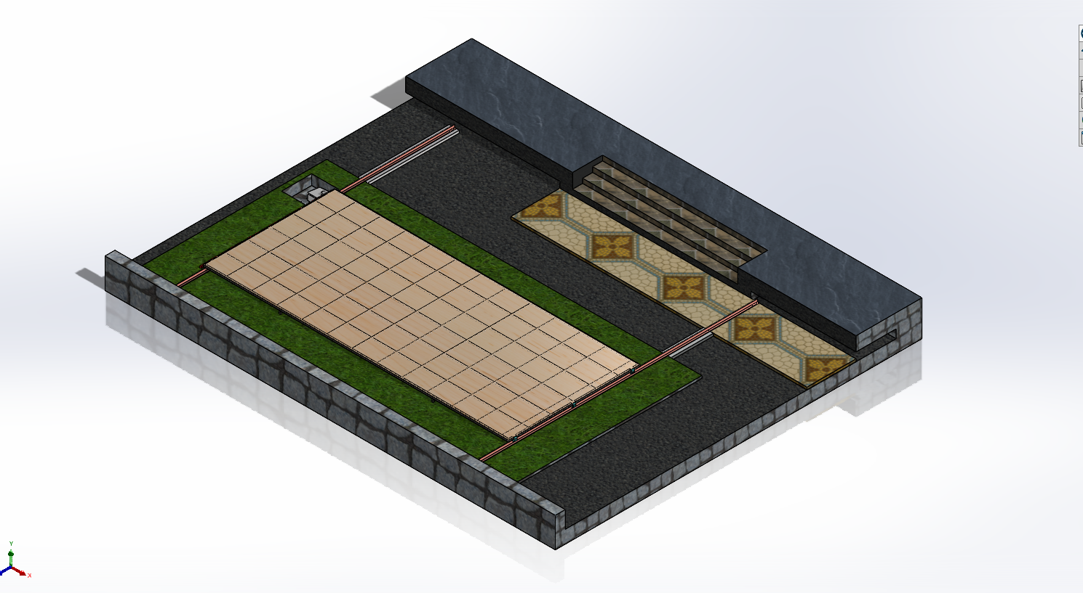

- On - First main power on the switch of Retractable Deck Automation Systems / Motor

- Deck open - Press open Remote control / Push button to open Retractable Deck gate, when motor is opening, the blue light will light on, once full open, motor stop by open limit, the blue light will off.



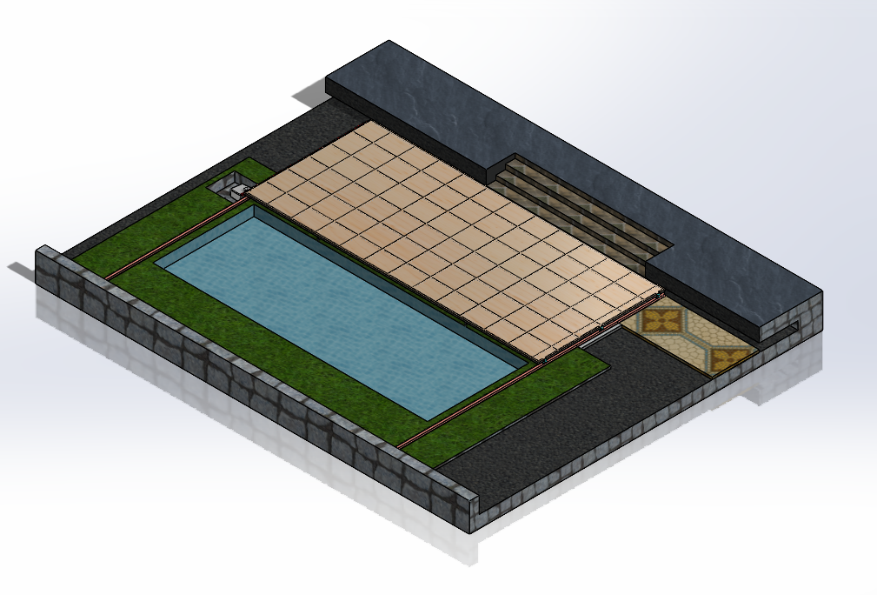

- Deck Close - Press close Remote control / Push Button to close the Retractable Roof, when motor is closing, the red light will light on, once full close, motor stop by close limit, the red light will off.

- Maximum continuous operating time (at nominal torque) 7 minutes ( The control unit limits continuous operation to the maximum value )

- Manual Operation - Manually release the gearmotor so that the gate can be opened and closed

The opener comes with an easy operating manual release. It brings the easiest manual release operation just in case of any emergency.

Insert the Release Key（provided）and turn it clockwise four turns to disengage the clutch between the gear shaft and power output. Now the opener is in manual operation.



Manual to Automation

Turn clutch anticlockwise four turns to engage the clutch between the gear shaft and power output. Lock the Release Key provided & remove it. Now the opener is in automation operation.


Guide Roller wheels should rotate easily and be free from dirt / grime.

- Warning:

Incorrect or improper use of this product can cause damage to persons, animals or properties.

Please ensure that the input voltage used matches with the supply voltage of gate opener
(AC220V±10% 50Hz).

More than 3 to 4 person never allow to stand on deck panel.

All modifications to wiring or electrics, and any adjustment or maintenance to 240VAC MUST be done by a qualified electrician.

Guide Roller wheels should rotate easily and be free from dirt / grime.
Make sure that Retractable Deck end stopper is each end ( Both End ) of the track to prevent the Deck travelling off the track.

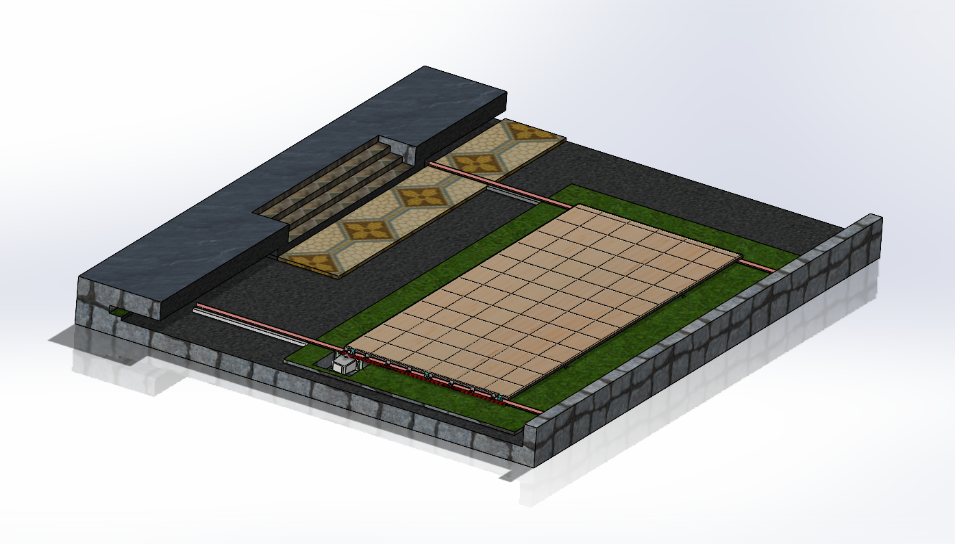

Never allow anyone to hang onto the Retractable Deck while moving.

Keep remote control and other control devices ( Push Button ) out of children’s reach, in order to avoid unintentional activation.

Ensure power plug is disconnected from the power socket during cleaning or maintenance

